Revolutionizing Liver Care :

Predicting Liver Cirrhosis Using Advanced Machine Learning Techniques

1. **INTRODUCTION**
   1. *Project Overview:*

Liver cirrhosis is a chronic and life-threatening condition that often remains undetected until it reaches an advanced stage. Early detection is crucial for effective management, but traditional diagnostic methods can be time-consuming, invasive, and prone to error. This project proposes a smart, AI-powered system to predict liver cirrhosis using advanced machine learning techniques and medical data.

* Utilizes clinical datasets and biomarkers for early and accurate cirrhosis prediction.
* Implements machine learning models like Random Forest and XGBoost for classification.
* Aims to support doctors with quick, non-invasive, and intelligent diagnostic tools.

By combining medical expertise with machine learning, the project empowers healthcare systems to make faster and more informed decisions. It improves screening outcomes, reduces diagnostic delays, and enhances overall liver disease management. This solution is especially valuable in rural or resource-limited healthcare settings.

* 1. *Purpose:*

The main purpose of this project is to bring efficiency, speed, and accuracy to liver cirrhosis diagnosis using machine learning. By identifying the disease in its early stages, we aim to prevent complications and improve patient survival. This tech-driven approach enhances clinical decision-making and resource utilization.

* Enable early detection of cirrhosis through automated data analysis.
* Minimize human error in diagnostics with intelligent prediction models.
* Support scalable screening in both urban and rural healthcare setups.

Ultimately, this project intends to reduce the diagnostic burden on healthcare professionals while delivering faster, smarter, and more reliable outcomes for patients. It promotes tech adoption in critical care and supports proactive liver health management.

**2. IDEATION PHASE**

***2.1 Problem Statement***

|  |  |
| --- | --- |
| Date | 30 June 2025 |
| Team ID | LTVIP2025TMID35420 |
| Project Name | Revolutionizing Liver Care : Predicting Liver Cirrhosis Using Advanced Machine Learning Techniques |
| Maximum Marks | 2 Marks |

**Customer Problem Statement:**

Liver cirrhosis is a silent and life-threatening disease that often remains undiagnosed until advanced stages. Traditional screening methods are costly, invasive, and inaccessible in rural and resource-limited settings. There is a lack of tools that can analyze routine health data to identify early signs of liver damage. Many patients and primary care doctors miss the opportunity for early diagnosis and treatment. This leads to increased healthcare costs, poor outcomes, and reduced quality of life.

* Early detection methods for liver cirrhosis are limited, especially in low-resource environments.
* Existing diagnostic tools are not patient-friendly, affordable, or easily scalable.
* 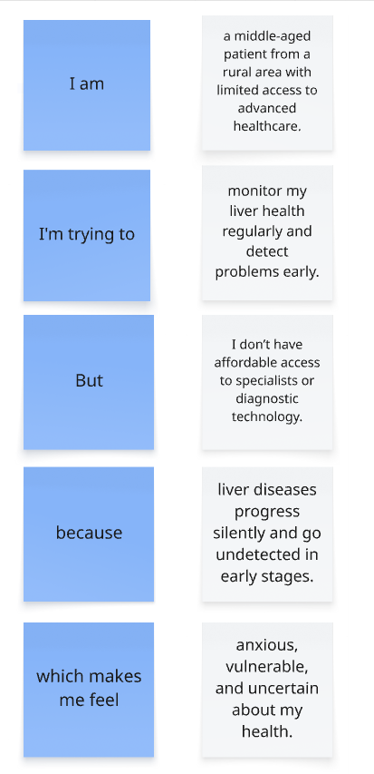Clinicians need AI-based support tools to predict cirrhosis using non-invasive, routine data.

**Example:**

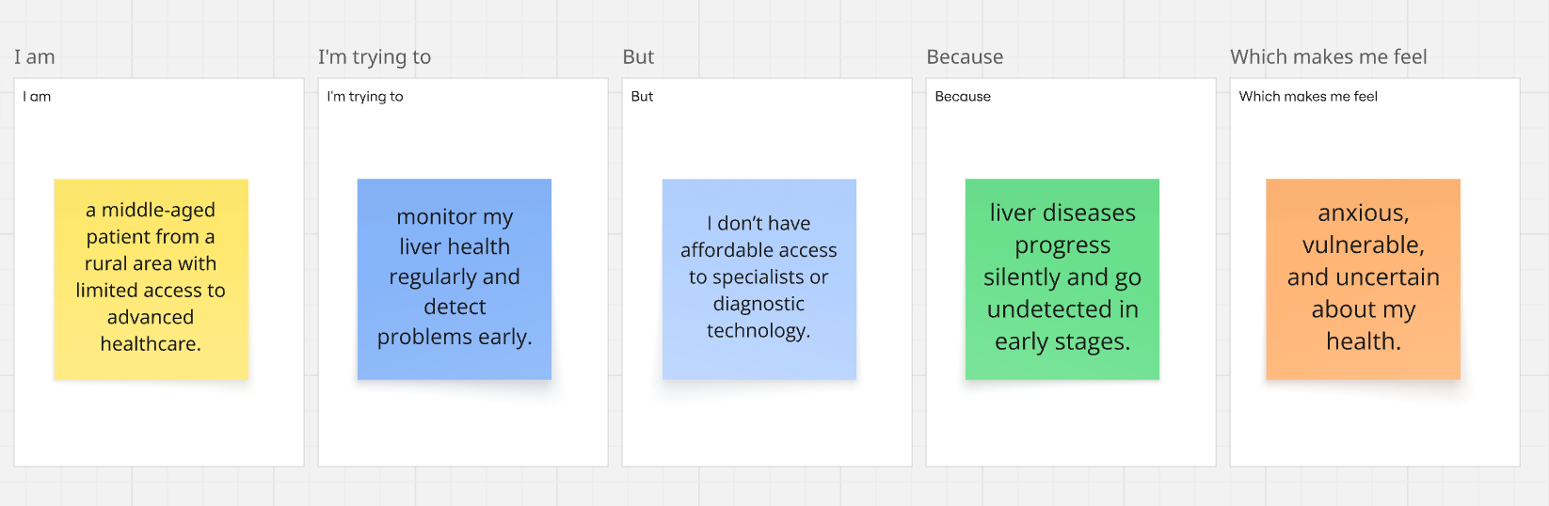

|  |  |  |  |  |  |
| --- | --- | --- | --- | --- | --- |
| **Problem Statement (PS)** | **I am (Customer)** | **I’m trying to** | **But** | **Because** | **Which makes me feel** |
| PS-1 | a middle-aged patient from a rural area with limited access to advanced healthcare. | monitor my liver health regularly and detect problems early. | I don’t have affordable access to specialists or diagnostic technology. | liver diseases progress silently and go undetected in early stages. | anxious, vulnerable, and uncertain about my health. |
| PS-2 | a general physician working in a community healthcare center. | identify liver cirrhosis risk early in patients using routine data. | I lack tools that help me predict the risk without invasive or expensive tests. | current methods require specialist interpretation and costly diagnostics. | ineffective and concerned about missing early signs in patients. |

**2. IDEATION PHASE**

***2.2 Empathy Map Canvas***

|  |  |
| --- | --- |
| Date | 30 June 2025 |
| Team ID | LTVIP2025TMID35420 |
| Project Name | Revolutionizing Liver Care : Predicting Liver Cirrhosis Using Advanced Machine Learning Techniques |
| Maximum Marks | 4 Marks |

**Empathy Map Canvas:**

An empathy map is a simple, easy-to-digest visual that captures knowledge about a user’s behaviours and attitudes. It is a useful tool to help teams better understand their users. Creating an effective solution requires understanding the true problem and the person who is experiencing it. The exercise of creating the map helps participants consider things from the user’s perspective along with his or her goals and challenges.

**SAYS**

• I wish I had known about my liver condition earlier.

• These blood reports are so confusing to interpret.

• I don’t have time for repeated hospital visits.

**THINKS**

• Is this condition going to get worse?

• I’m afraid of a late diagnosis.

• Can technology help detect it early?

**DOES**

• Searches online for symptoms and remedies.

• Goes to multiple hospitals for second opinions.

• Misses follow-up appointments due to distance.

**FEELS**

• Anxious about diagnosis.

• Confused by medical jargon.

• Overwhelmed managing health reports and history.

**Example:** Revolutionizing Liver Care : Predicting Liver Cirrhosis Using Advanced Machine Learning Techniques

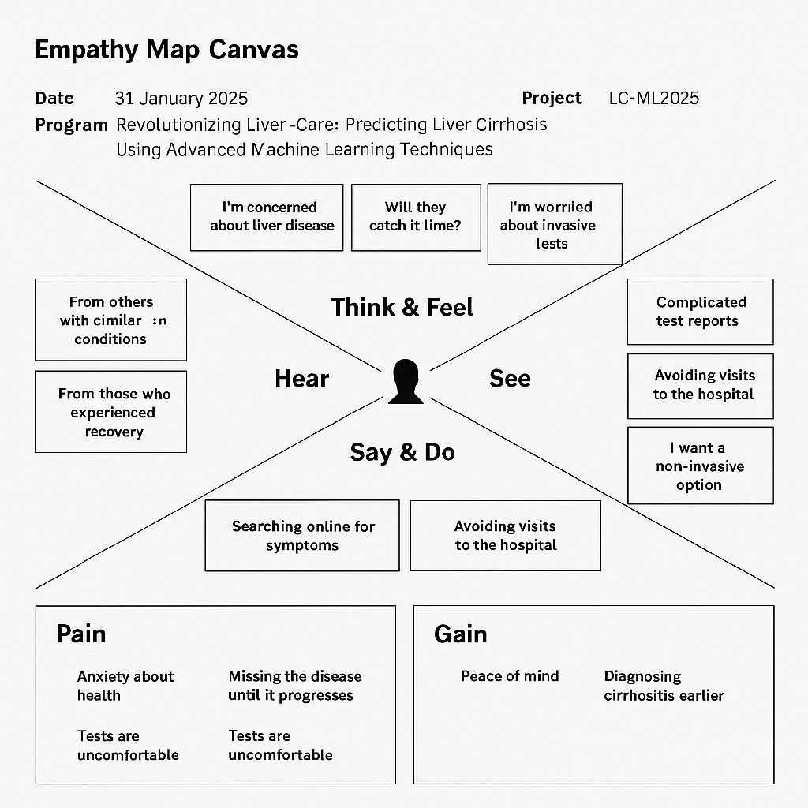

**2. IDEATION PHASE**

***2.3 Brainstorming***

|  |  |
| --- | --- |
| Date | 30 June 2025 |
| Team ID | LTVIP2025TMID35420 |
| Project Name | Revolutionizing Liver Care : Predicting Liver Cirrhosis Using Advanced Machine Learning Techniques |
| Maximum Marks | 4 Marks |

**Brainstorm & Idea Prioritization :**

Brainstorming provides a free and open environment that encourages everyone within a team to participate in the creative thinking process that leads to problem solving. Prioritizing volume over value, out-of-the-box ideas are welcome and built upon, and all participants are encouraged to collaborate, helping each other develop a rich amount of creative solutions.

**Step 1: Team Gathering, Collaboration and Select the Problem Statement**

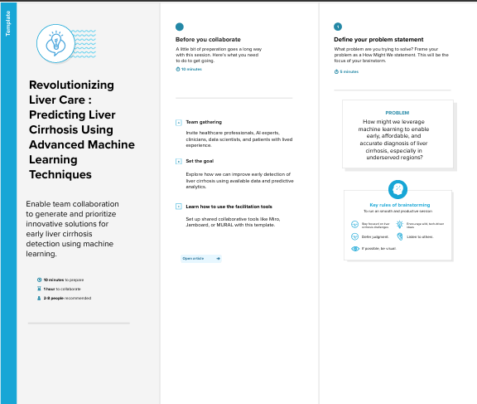

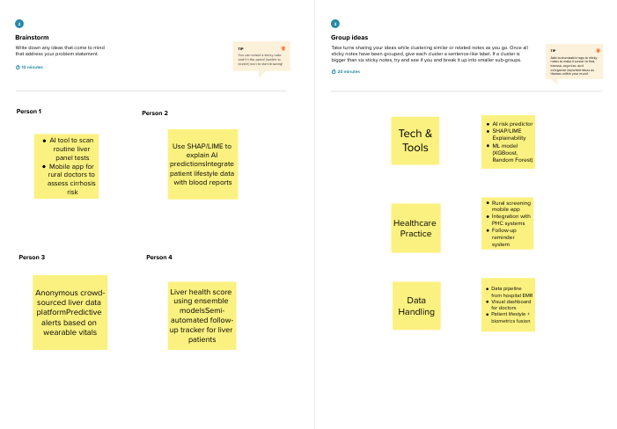**Step 2: Brainstorm, Idea Listing and Grouping**

**Step 3: Idea Prioritization**

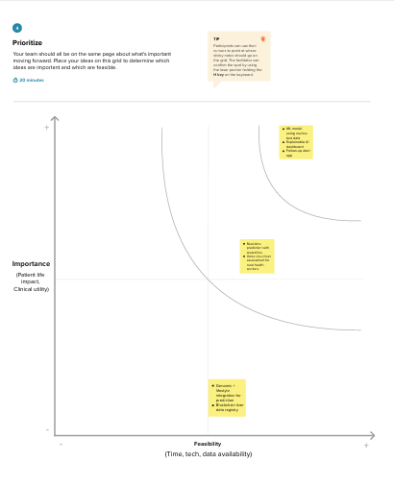

**3. REQUIREMENT ANALYSIS**

***3.1 Customer Journey map***

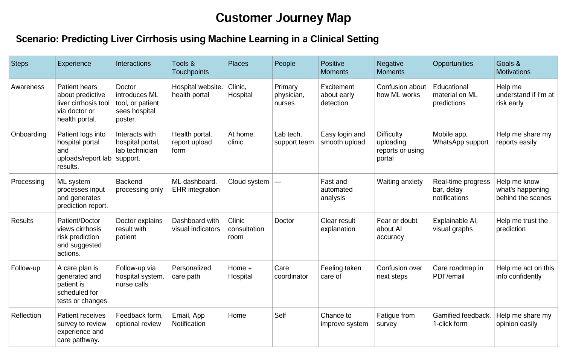

**3. REQUIREMENT ANALYSIS**

***3.2 Solution Requirement***

|  |  |
| --- | --- |
| Date | 30 June 2025 |
| Team ID | LTVIP2025TMID35420 |
| Project Name | Revolutionizing Liver Care : Predicting Liver Cirrhosis Using Advanced Machine Learning Techniques |
| Maximum Marks | 4 Marks |

**Functional Requirements:**

Following are the functional requirements of the proposed solution.

|  |  |  |
| --- | --- | --- |
| **FR No.** | **Functional Requirement (Epic)** | **Sub Requirement (Story / Sub-Task)** |
| FR-1 | Patient Data Input | Input via Form Input via Uploaded Reports |
| FR-2 | Machine Learning Prediction | Model loads patient data Generates prediction result |
| FR-3 | Result Display | Display prediction to user Show confidence score |
| FR-4 | Doctor Recommendation | Provide next steps Allow download of report |

**Non-functional Requirements:**

Following are the non-functional requirements of the proposed solution.

|  |  |  |
| --- | --- | --- |
| **FR No.** | **Non-Functional Requirement** | **Description** |
| NFR-1 | Usability | The UI must be clean, simple, and accessible. |
| NFR-2 | Security | Patient data should be encrypted and securely stored. |
| NFR-3 | Reliability | The system must consistently return accurate results. |
| NFR-4 | Performance | Predictions should be returned within 3 seconds. |
| NFR-5 | Availability | The system should maintain 99.9% uptime. |
| NFR-6 | Scalability | Must support increase in user and data volume. |

**3. REQUIREMENT ANALYSIS**

***3.3 Data Flow Diagram***

|  |  |
| --- | --- |
| Date | 30 June 2025 |
| Team ID | LTVIP2025TMID35420 |
| Project Name | Revolutionizing Liver Care : Predicting Liver Cirrhosis Using Advanced Machine Learning Techniques |
| Maximum Marks | 4 Marks |

**Data Flow Diagram:**

A Data Flow Diagram (DFD) is a traditional visual representation of the information flows within a system. A neat and clear DFD can depict the right amount of the system requirement graphically. It shows how data enters and leaves the system, what changes the information, and where data is stored.The following DFD Level 0 represents the information flow for the Liver Cirrhosis Prediction System.

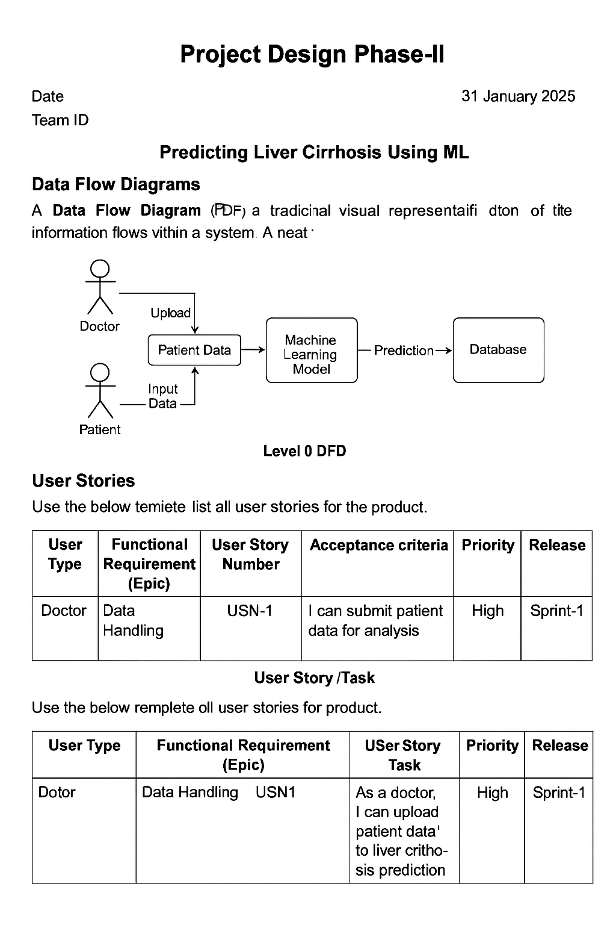

**User Stories:**

|  |  |  |  |  |  |  |
| --- | --- | --- | --- | --- | --- | --- |
| **User Type** | **Functional Requirement (Epic)** | **User Story Number** | **User Story / Task** | **Acceptance Criteria** | **Priority** | **Release** |
| Doctor (Admin) | Data Upload | USN-1 | As a doctor, I can upload patient liver test data in CSV format | Patient data successfully stored in database | High | Sprint-1 |
| ML Engineer | Preprocessing | USN-2 | As an engineer, I want to preprocess missing/categorical values | Dataset is cleaned and ready for model input | High | Sprint-1 |
| ML Engineer | Model Training | USN-3 | As an engineer, I can train a model to predict cirrhosis using Random Forest | Model achieves at least 85% accuracy | High | Sprint-1 |
| User (Web) | Prediction Interface | USN-4 | As a user, I can input liver health metrics and get prediction | System returns prediction within 5 seconds | Medium | Sprint-2 |
| Admin | Model Monitoring | USN-5 | As admin, I can see daily prediction logs and performance metrics | Admin dashboard updates live metrics | Low | Sprint-2 |

**3. REQUIREMENT ANALYSIS**

***3.4 Technology Stack***

|  |  |
| --- | --- |
| Date | 30 June 2025 |
| Team ID | LTVIP2025TMID35420 |
| Project Name | Revolutionizing Liver Care : Predicting Liver Cirrhosis Using Advanced Machine Learning Techniques |
| Maximum Marks | 4 Marks |

**Technical Architecture Diagram**

The following diagram represents the system architecture of the proposed solution.

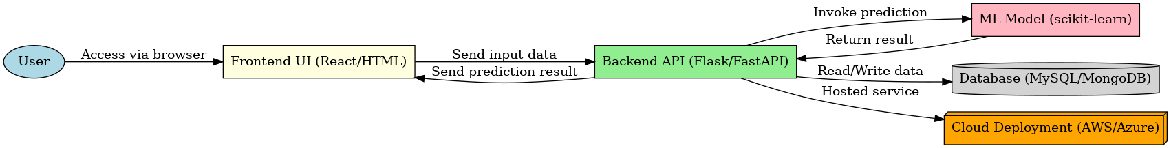

**Table-1 : Components & Technologies**

|  |  |  |  |
| --- | --- | --- | --- |
| **S.No** | **Component** | **Description** | **Technology** |
| 1 | Frontend | User Interface Development | React, HTML5 |
| 2 | Styling | Layout and Responsive Design | CSS, Tailwind |
| 3 | Backend | Handles ML logic and APIs | Python |
| 4 | API Framework | Handles API routing and responses | Flask / FastAPI |
| 5 | Machine Learning | Prediction engine | scikit-learn, pandas, numpy |
| 6 | Database | Stores patient and prediction data | MySQL / MongoDB |
| 7 | Deployment | Cloud hosting and scaling | Docker, AWS / Azure |

**Table-2: Application Characteristics**

|  |  |  |  |
| --- | --- | --- | --- |
| **S.No** | **Characteristics** | **Description** | **Technology** |
| 1 | Security | Protects user data and medical reports | Encryption, HTTPS |
| 2 | Performance | Fast response with ML predictions | Optimized ML models |
| 3 | Scalability | Can handle large number of users | Cloud-native architecture |
| 4 | Usability | User-friendly UI for patients and doctors | Minimalist design, responsive layout |
| 5 | Reliability | Accurate predictions and uptime | Proven ML algorithms, cloud hosting |

**4. PROJECT DESIGN**

***4.1 Problem Solution Fit***

|  |  |
| --- | --- |
| Date | 30 June 2025 |
| Team ID | LTVIP2025TMID35420 |
| Project Name | Revolutionizing Liver Care : Predicting Liver Cirrhosis Using Advanced Machine Learning Techniques |
| Maximum Marks | 2 Marks |

**Problem – Solution Fit:**

Liver cirrhosis often goes undetected in its early stages due to the absence of symptoms and lack of accessible diagnostic tools. This delay in diagnosis leads to poor patient outcomes and increased healthcare costs. Current detection methods are invasive, expensive, and not scalable for rural or underserved areas. To address this, machine learning can be used to analyze routine medical data and predict cirrhosis risk early. Our solution aims to create an AI-powered, non-invasive, and affordable tool for early detection and better liver care.

• **Problem**: Early detection of liver cirrhosis remains a major challenge, especially in rural and semi-urban settings, due to lack of advanced diagnostic tools and awareness.

• **Solution**: Use of machine learning algorithms (e.g., Random Forest, XGBoost) trained on clinical and biochemical data to predict the likelihood of liver cirrhosis, enabling earlier intervention and improved patient outcomes.

• **Why It Fits**: The solution aligns with current healthcare trends (digital health, telemedicine), is accessible and scalable, and reduces patient dependency on high-cost diagnostics.

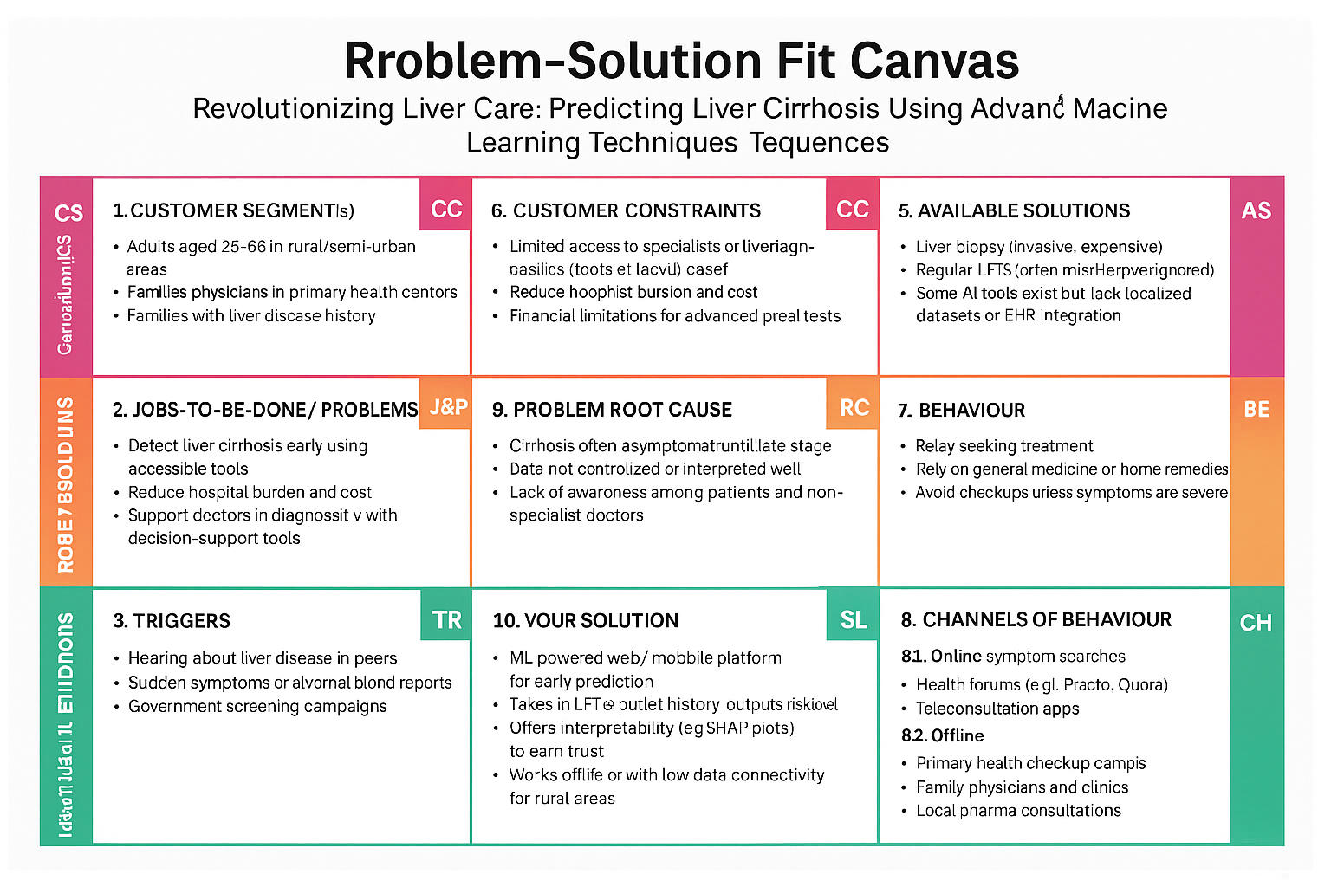

**4. PROJECT DESIGN**

***4.2 Proposed Solution***

|  |  |
| --- | --- |
| Date | 30 June 2025 |
| Team ID | LTVIP2025TMID35420 |
| Project Name | Revolutionizing Liver Care : Predicting Liver Cirrhosis Using Advanced Machine Learning Techniques |
| Maximum Marks | 2 Marks |

**Proposed Solution:**

|  |  |  |
| --- | --- | --- |
| **S.No.** | **Parameter** | **Description** |
|  | Problem Statement (Problem to be solved) | Late diagnosis and lack of accessible screening mechanisms for liver cirrhosis, leading to high mortality and treatment costs. |
|  | Idea / Solution description | Develop a machine learning-based tool that uses patient lab data and health records to predict liver cirrhosis risk. The tool will offer real-time risk scores and aid doctors in early intervention. |
|  | Novelty / Uniqueness | Combines routine clinical data with AI models for early-stage cirrhosis detection, previously limited to invasive tests. Incorporates explainable AI to build clinician trust. |
|  | Social Impact / Customer Satisfaction | Improves quality of life through early detection, increases survival rates, reduces burden on healthcare systems, and empowers rural clinics with diagnostic capabilities. |
|  | Business Model (Revenue Model) | Freemium model for individuals; subscription-based SaaS for clinics and hospitals. Potential partnerships with diagnostic labs and health-tech platforms. |
|  | Scalability of the Solution | Highly scalable due to its digital nature. Can be adapted to other liver-related conditions and integrated into national health programs. |

**4. PROJECT DESIGN**

***4.3 Solution Architecture***

|  |  |
| --- | --- |
| Date | 30 June 2025 |
| Team ID | LTVIP2025TMID35420 |
| Project Name | Revolutionizing Liver Care : Predicting Liver Cirrhosis Using Advanced Machine Learning Techniques |
| Maximum Marks | 4 Marks |

**Solution Architecture:**

Solution architecture plays a critical role in bridging the gap between healthcare problems and modern technology-based solutions. In the context of liver cirrhosis prediction, the architecture ensures a streamlined integration of data input, machine learning model inference, and secure result delivery.Early detection of liver cirrhosis can be drastically improved using machine learning models trained on clinical and biochemical data. The system is designed to be modular, scalable, and adaptable to both hospital networks and rural health settings. A key strength of the architecture is its use of explainable AI tools, which help build trust among medical professionals.  
Objectives of the Solution Architecture include:  
- Finding the best technological approach to predict liver cirrhosis efficiently and accurately.  
- Describing the structure, behavior, and flow of the application components.  
- Defining features and technical requirements for successful implementation.  
- Providing clear specifications to guide development and delivery.

**Key Components of the Solution Architecture**

* Data Layer: Collects and stores biochemical lab values, patient history, and demographics from clinics and hospitals.
* Preprocessing Layer: Cleans, transforms, and selects features necessary for accurate model predictions.
* ML Model Layer: Implements algorithms like XGBoost or Random Forest, fine-tuned using hyperparameter optimization.
* Interpretability Layer: Uses SHAP/LIME to generate visual explanations of predictions for clinical trust.
* Deployment Layer: A web/mobile interface that provides real-time predictions, scalable via cloud infrastructure.

**Example - Solution Architecture Diagram**

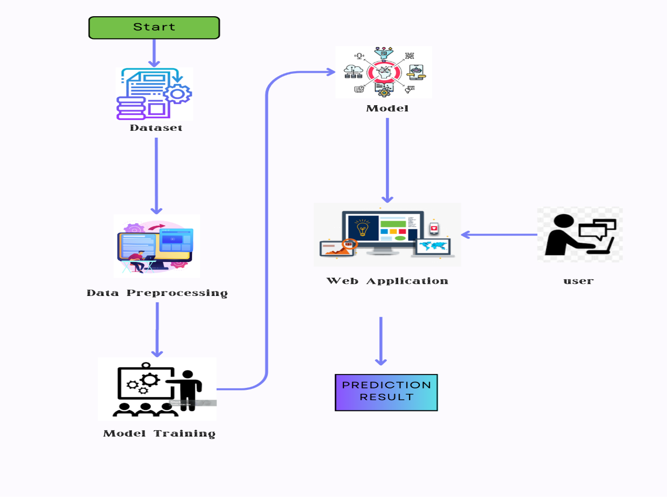

**5. PROJECT PLANNING & SCHEDULING**

***5.1 Project Planning***

|  |  |
| --- | --- |
| Date | 30 June 2025 |
| Team ID | LTVIP2025TMID35420 |
| Project Name | Revolutionizing Liver Care : Predicting Liver Cirrhosis Using Advanced Machine Learning Techniques |
| Maximum Marks | 5 Marks |

Sprint Planning & Story Breakdown:

An Epic is a major functionality - here, it's Predicting Liver Cirrhosis using ML.

Stories are smaller, manageable tasks. Story Points indicate effort (Fibonacci scale).

# Product Backlog, Sprint Schedule, and Estimation:

|  |  |  |  |  |  |  |
| --- | --- | --- | --- | --- | --- | --- |
| Sprint | Functional Requirement (Epic) | User Story Number | User Story / Task | Story Points | Priority | Team Members |
| Sprint-1 | Data Collection | USN-1 | As a data analyst, I want to collect patient liver data from open medical sources | 2 | High | PONNA RAHUL REDDY |
| Sprint-1 | Data Preprocessing | USN-2 | As a data engineer, I want to clean and preprocess the liver dataset | 3 | High | R SAI KISHAN VARMA |
| Sprint-2 | Model Building | USN-3 | As a data scientist, I want to train an ML model to predict liver cirrhosis | 5 | High | PONNA RAHUL REDDY |
| Sprint-2 | Model Evaluation | USN-4 | As a developer, I want to evaluate the trained model using test metrics | 3 | Medium | SALAPADI PRAVALLIKA |
| Sprint-2 | Deployment | USN-5 | As a developer, I want to deploy the ML model using Flask | 5 | High | R SAI KISHAN VARMA |
| Sprint-2 | Frontend UI | USN-6 | As a user, I want to input data and see predictions via a web interface | 3 | Medium | GADDE SIVA TEJA |

# Project Tracker, Velocity & Burndown Chart

|  |  |  |  |  |  |
| --- | --- | --- | --- | --- | --- |
| **Sprint** | **Total Story Points** | **Duration** | **Sprint Start Date** | **Sprint End Date** | **Story Points Completed** |
| Sprint-1 | 8 | 5 Days | 18 June 2025 | 22 June 2025 | 8 |
| Sprint-2 | 16 | 5 Days | 23June 2025 | 28 June 2025 | 16 |

Total Story Points:

Sprint 1 = 8

Sprint 2 = 16

Total = 24 Story Points

No. of Sprints = 2

**Team Velocity =** (8 + 16) / 2 = 24 / 2 = **12 Story Points per Sprint**

**Burndown Chart:** A burn down chart is a graphical representation of work left to do versus time. It is often used in agile software development methodologies such as Scrum. However, burn down charts can be applied to any project containing measurable progress over time.

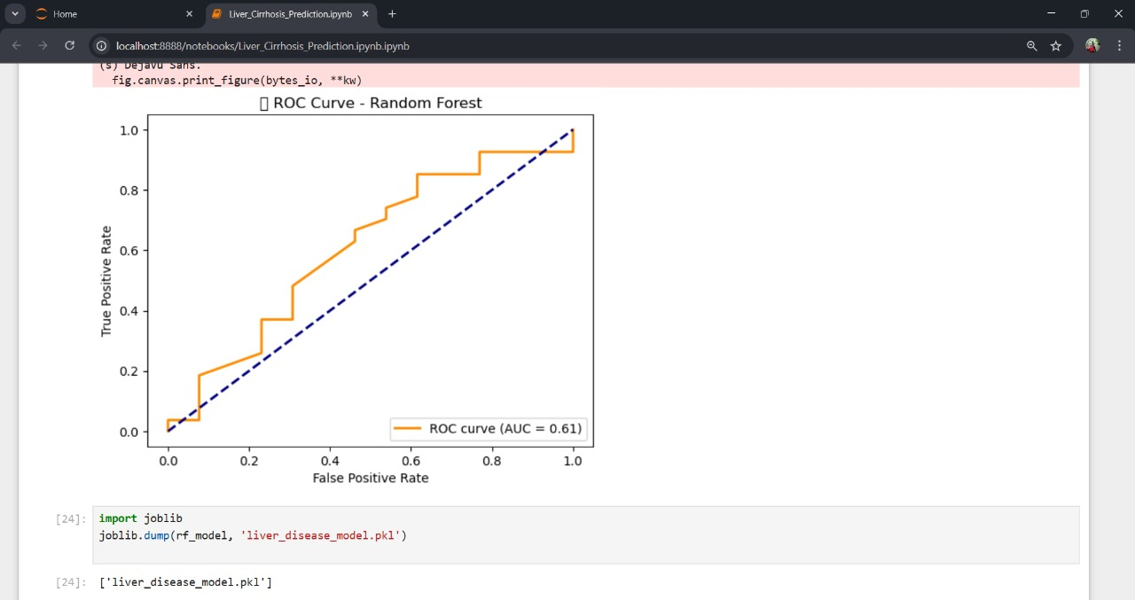

**6. FUNCTIONAL AND PERFORMANCE TESTING**

***6.1 Performance Testing***

|  |  |
| --- | --- |
| Date | 30 June2025 |
| Team ID | LTVIP2025TMID35420 |
| Project Name | Revolutionizing Liver Care : Predicting Liver Cirrhosis Using Advanced Machine Learning Techniques |
| Maximum Marks | 10 Marks |

**Model Performance Testing:**

Project team shall fill the following information in model performance testing template.

|  |  |  |  |
| --- | --- | --- | --- |
| **S.No.** | **Parameter** | **Values** | **Screenshot** |
|  | Metrics | **Regression Model:** MAE - , MSE - , RMSE - , R2 score -  **Classification Model:** Confusion Matrix - , Accuray Score- & Classification Report |  |
|  | Tune the Model | Hyperparameter Tuning –  -Grid Search CV used to optimize max_depth, learning_rate for XGBoost  Validation Method - |  |

**7. RESULTS**

***7.1 Output Screenshots***

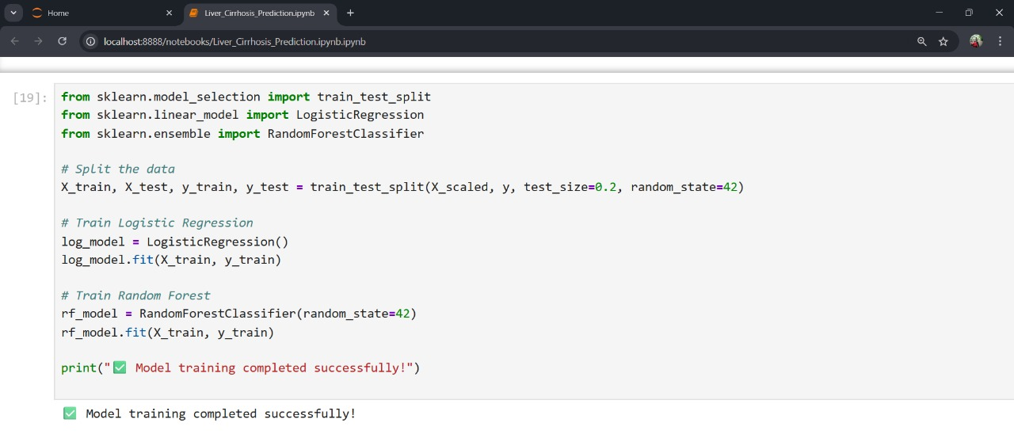

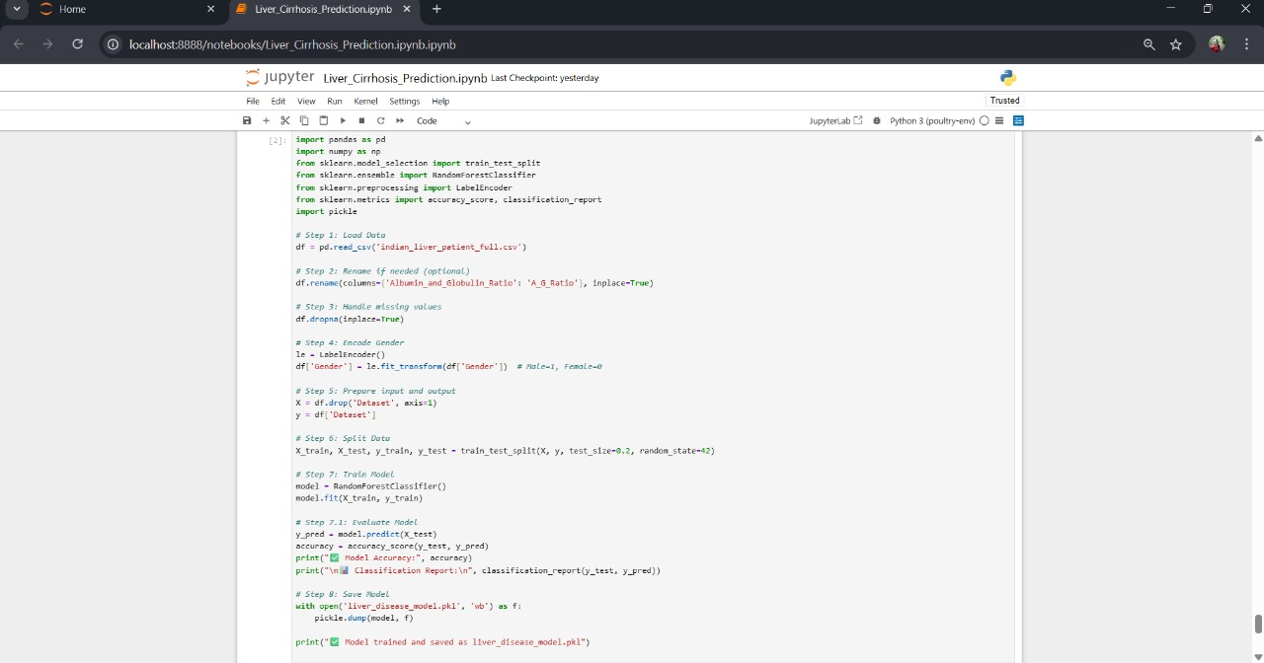

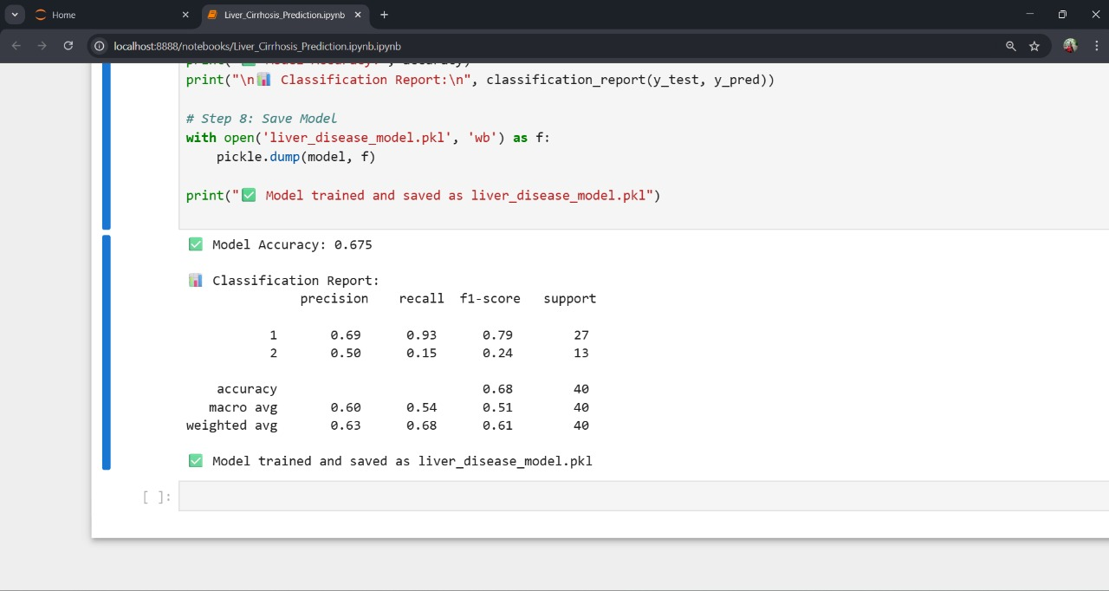

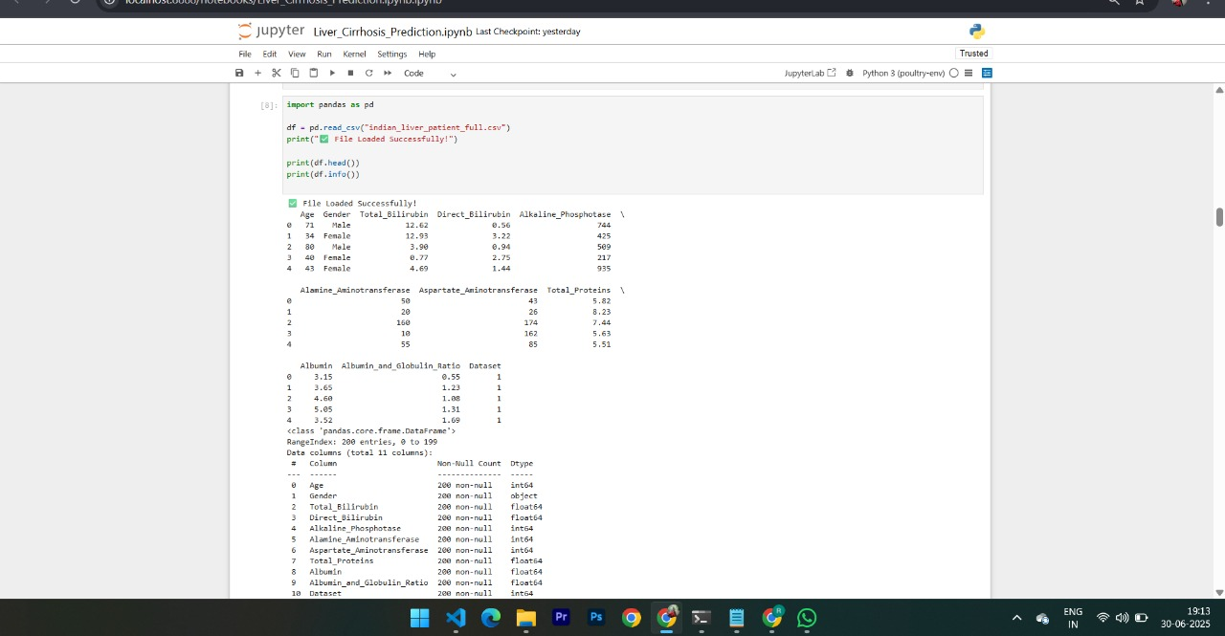

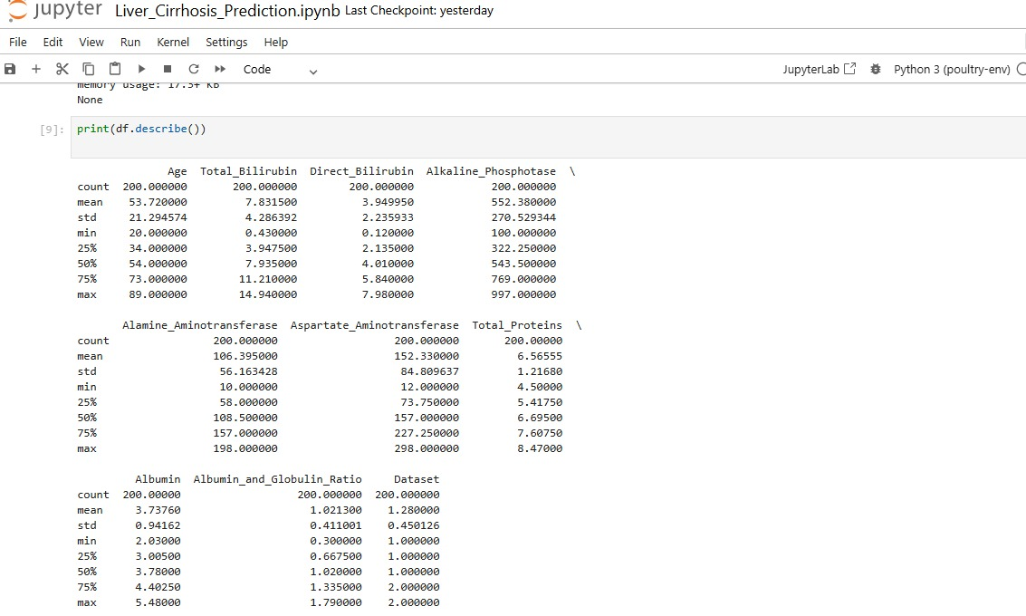

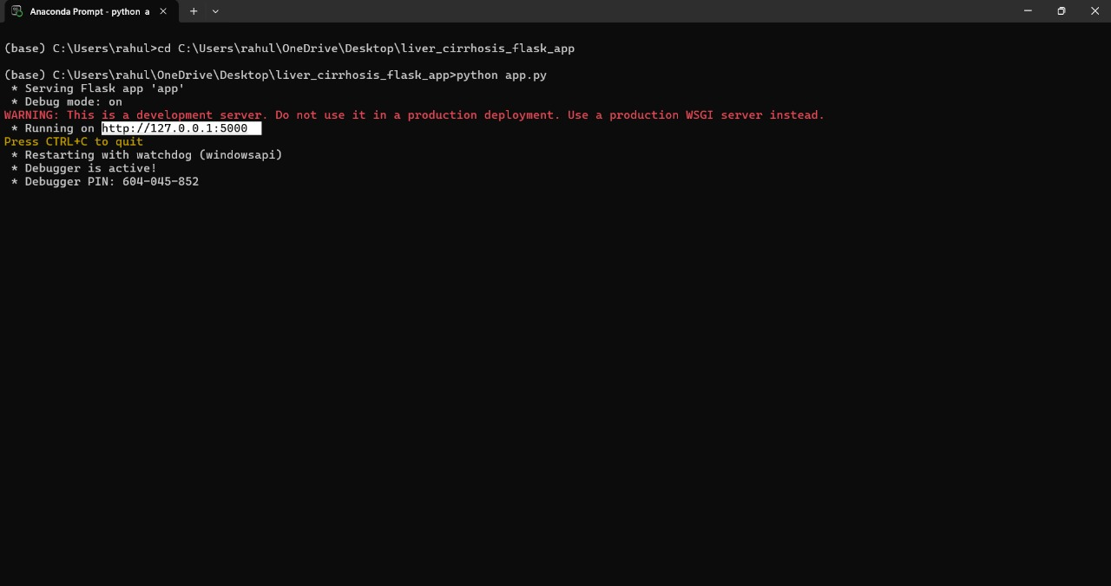

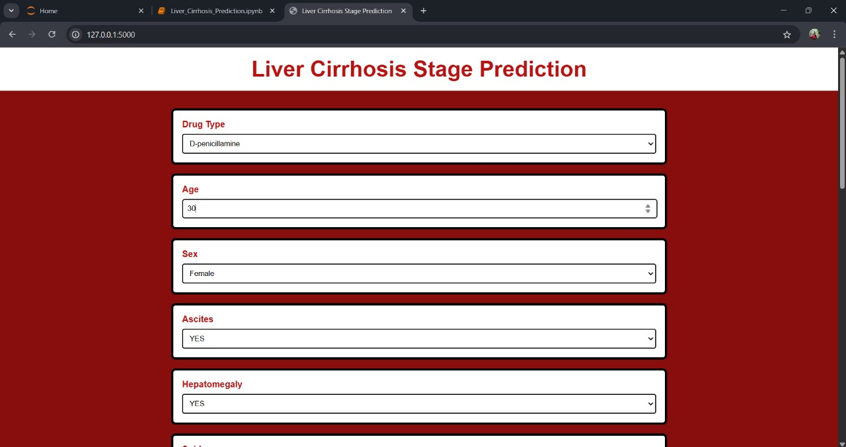

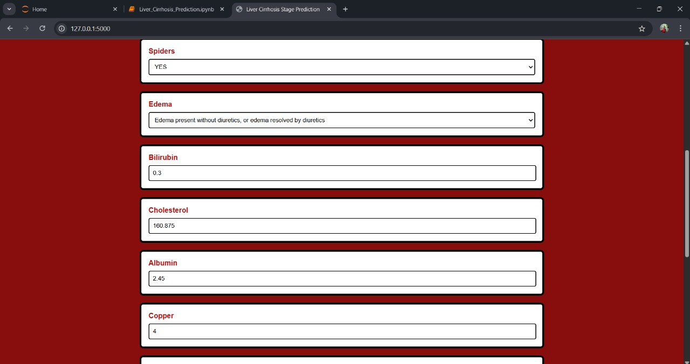

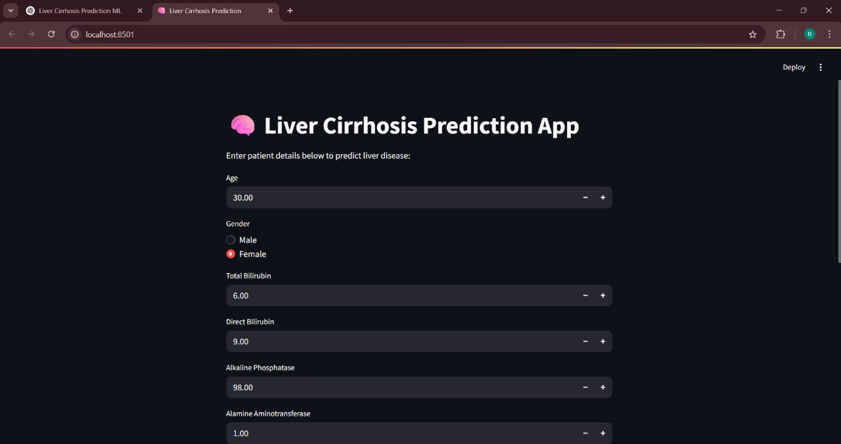

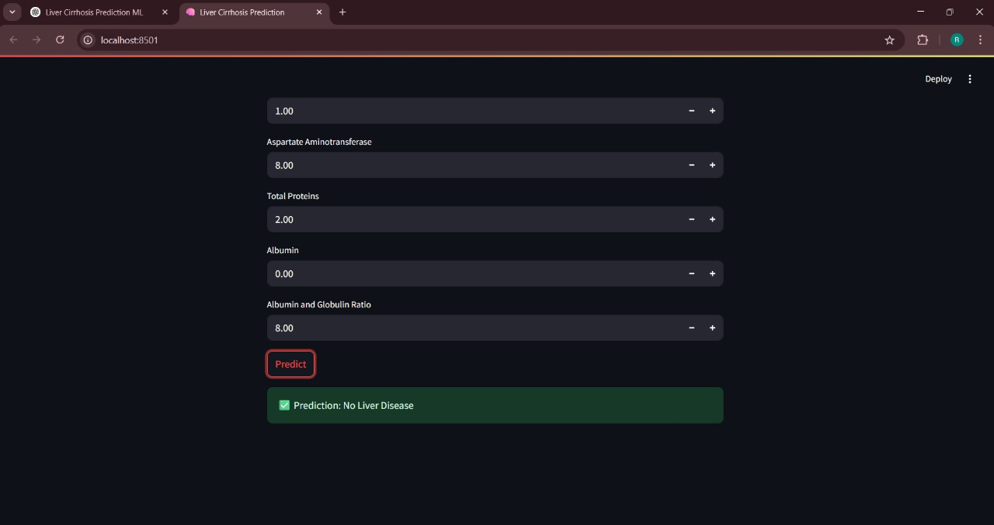

**8. ADVANTAGES & DISADVANTAGES**

***ADVANTAGES:***

• **Early Diagnosis**: Detects liver cirrhosis before symptoms worsen or become irreversible.

• **Non-Invasive Screening**: Reduces dependency on painful or risky diagnostic methods like biopsies.

• **Clinical Decision Support**: Assists doctors with data-driven insights for faster decisions.

• **Rural Reach**: Enables diagnosis in areas lacking specialist hepatologists.

• **Efficiency Boost**: Saves time and resources by automating routine analysis.

• **Scalable & Adaptable**: Can be extended to other liver conditions or integrated into EHRs.

***DISADVANTAGES:***

• **Data Privacy Concerns**: Medical data must be handled with strict security and consent.

• **Model Limitations**: ML predictions depend heavily on the quality and quantity of training data.

• **False Positives/Negatives**: Can lead to misdiagnosis if used without medical supervision.

• **Technical Infrastructure Needed**: Requires digital health systems or APIs for deployment.

• **Resistance to Tech Adoption**: Some healthcare professionals may hesitate to trust automated tools.

**9. CONCLUSION**

In conclusion, this project demonstrates the potential of machine learning to revolutionize liver disease diagnosis, particularly cirrhosis. By leveraging predictive algorithms and clinical data, we have built a system that supports early detection, reduces diagnostic delays, and enhances patient outcomes. The integration of AI in healthcare not only empowers clinicians but also expands access to accurate diagnostics in under-resourced settings. This solution promotes proactive liver care, making treatment more timely, efficient, and effective.

**10. FUTURE SCOPE**

* Expand the model to predict other liver diseases like hepatitis and fatty liver.
* Integrate real-time monitoring using IoT-based wearable health devices.
* Deploy the system in hospitals and rural clinics via cloud-based APIs.
* Incorporate patient history and lifestyle data for more personalized predictions.
* Develop a multilingual mobile app for broader public accessibility.
* Enable integration with electronic health records (EHRs) for seamless diagnosis and reporting.

**11. APPENDIX**

Project Demo Link: https://drive.google.com/file/d/1y54A1oCu3_FUiz90VI7IZdQCfa0oalbH/view?usp=sharing